**10th September , 2024**

**Muhammad Shafeen**

22P-9278

BAI - 5A

**Ms.Noureen Shah**

Subject Coordinator,

Fast National University of Computer And Emerging Sciences, Peshawar.

**Subject :** Requesting quiz - I review and marks re-evaluation

Respected Madam,

I am requesting on behalf of the quiz taken last week.I feel like my grading

Sincerely,

**Muhammad Shafeen**

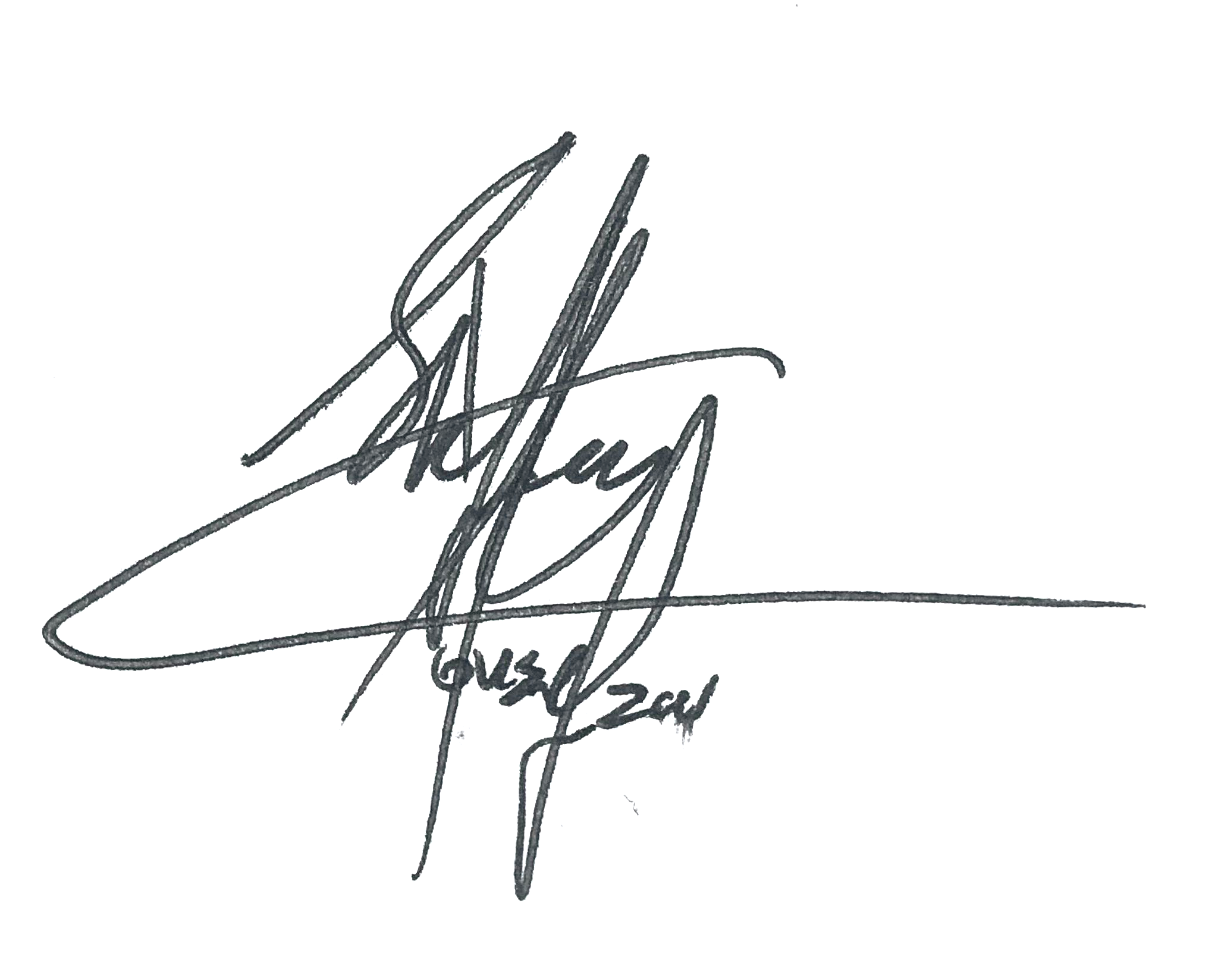

Student.